Index Hybrid

Simple Order Processing with autoex
Test Plan

Wege Kifle
ITG
Table of Contents

Test Setting 4
Order Validation & Function 5
Test Case 1. Verify that CBOEdirect ONLY accepts ‘I’ order with Contingency OPG and IOC for Index Hybrid Enabled Class 5
Test Case 2. Verify that Auto-Ex is applied after Opening Trade ONLY 6
Test Case 3. Verify that Auto-Ex is applied to incoming Customer order only 7
Test Case 4. Verify that Auto-Ex is applied to resting orders with origin type other than ‘C’, ‘D’ and ‘X’ only 7
Test Case 5. Verify that Auto-Ex is not applied during Quote Lock & Quote Trigger 8
Test Case 6. Verify that Auto Ex is not applied for incoming Customer order, except for AON and FOK orders, after auction is started. 9
Test Case 7. Verify that incoming marketable Customer order trades only with resting non-Q like order when Auto ex size is set to Zero; order routs back to TPF if book has no resting marketable non-Q like order. 13
Test Case 8. Incoming marketable Volume Contingency AON & FOK order does not trade with book when max tradable qty (customer order book size + Auto ex size) is less than the incoming order qty, Verify that order is routed back to TPF. 14
Test Case 9. Incoming marketable Contingency IOC order trades with book up to the max tradable qty (customer order book size + Auto ex size) & the remaining order qty is routed back to TPF. 18
Test Case 10. Quote qty is less than Auto Ex size, Verify that incoming marketable customer order trades with quote & remaining qty is booked 19
Test Case 11. Incoming Customer order from PAR with T/A; Verify that Auto ex is applied at each time Customer order is received from PAR 21
Test Case 12. Auction will not start for various reasons for incoming Contingency orders from SBT; Order trades up to Auto Ex size and the remaining is routed back to PAR, Then send order from PAR to SBT using T/A, T/B & Book. Verity results. 22
Incoming Customer order from PAR with BOOK: 24
Test Scenario 13. Book has resting Auto Quote & Customer Order, Verify the following incoming Contingency Orders (AON, FOK, IOC) from PAR with instruction to Book 24
Test Scenario 14. Book has resting Auto Quote, Customer Order, and Manual Quote, Verify the following incoming Contingency Orders (AON, FOK, IOC,) from PAR with instruction to Book 26
Incoming I-order from PAR with BOOK: 27
Test Scenario 15. Book has resting Auto Quote, Verify that Incoming I-IOC order from PAR with instruction to Book starts a Quote Lock & trades with book, the remaining qty is canceled 27
Test Scenario 16. Book has resting Auto Quote & Customer Order, Verify that Incoming I-IOC order from PAR with instruction to Book starts a Quote Trigger/Quote Lock & trades with book, the remaining qty is canceled 27
Test Scenario 17. Book has resting Auto Quote, Manual Quote & Customer Order, Verify that Incoming I-IOC order from PAR with instruction to Book cancel resting Manual Quote & starts a Quote Trigger/Quote Lock, then trades with book, the remaining qty is canceled 28
Incoming order from PAR with T/A: 29
Test Scenario 18. Book has resting Auto Quote, Verify the following incoming Customer Orders from PAR with instruction T/A 29
Test Scenario 19. Book has resting Auto Quote & Customer Order, Verify the following incoming Customer Orders from PAR with instruction T/A 30
Test Scenario 20. Book has resting Auto Quote & Customer Order and Manual Quote, Verify the following incoming Customer Orders from PAR with instruction T/A 31
Incoming order from PAR with T/B: 32
Test Scenario 21. Book has resting Auto Quote, Verify the following incoming Customer Orders from PAR with instruction T/B 32
Test Scenario 22. Book has resting Auto Quote & Customer Order, Verify the following incoming Customer Orders from PAR with instruction T/B 33
Test Scenario 23. Book has resting Auto Quote & Customer Order and Manual Quote, Verify the following incoming Customer Orders from PAR with instruction T/B 34
APPENDIX A – TPF SETTINGS: 35

Test Setting

Trading Property Setting

- Auction Enabled to FLASE for HAL (4), SAL (5), & AIM (1): (unless specified in the test case)
- Auction Min Max Order Size to 1(lower limit) and 10000(upper limit) for HAL (4) & SAL (5) and AIM (1) to 50 (lower limit) & 10000(upper limit)
- Auction Min Number Of Quoters to 1 for HAL (4), SAL (5), & AIM (1):
- Auction Min Price Increment to 1 for HAL (4), SAL (5), & AIM (1):
- Auction Minimum Order Size For Ticks Above NBBO to 1 for AIM (1), HAL (4) & SAL (5)
- Auction Order Ticks Away From NBBO to 1 for HAL (4), SAL (5), & AIM (1):
- Auction Receiver Type to 1-ClassQuoter for HAL (4), SAL (5), & AIM (1):
- Auction Time To Live to value that will be long enough to execute your test events before auction expires for HAL (4), SAL (5), & AIM (1):
- Quote Lock Timer long enough to enter the required sequence of events
- Quote Trigger Timer long enough to enter the required sequence of events
- Auto Ex Size Against Non Customer to 9999999: (unless specified in the test case)
- Index Hybrid Indicator is set to TRUE for your class: (unless specified in the test case)
- Book Depth Size to 5 for your Test class: (unless specified in the test case)
- MOC Interval Seconds to a time to trigger order immediately (unless specified in the test case)
- Manual Quote Cancel Timer For PAR long enough to execute your test events before timer expires: (unless specified in the test case)
- Manual Quote Cancel Timer For Non PAR long enough to execute your test events before timer expires: (unless specified in the test case)

- Make sure that ALL MMs are subscribed for HAL (4), SAL (5), and AIM (1) auction in order to enter RFPs and to participate in the Auction.
- Make sure the order book for the product is empty before testing each Test Cases/Scenarios.
- Make sure system is connected to TPF & your Class is Enabled for Index Hybrid From TPF

Order Validation & Function

Test Case 1 Verify that CBOEdirect ONLY accepts ‘I’ order with Contingency OPG and IOC for Index Hybrid Enabled Class

  - Set Product to Pre-Open
  - MM Enters Quote: 1.00 x 100 – 1.10 x 100
  - MM2 Enters ‘I’ OPG order: Buy 15@1.10
  - Verify Current Market 1.10 x 15 – 1.10 x 100
  - Set Product to Opening-Rotation
Result:
    - After product opens MM2 ‘I’ OPG order trades with MM Quote for 15@1.10
    - Verify Current Market 1.00 x 100 – 1.10 x 85

  - MM3 Enters ‘I’ IOC order: Sell 25@0.95
    - ‘I’ IOC Order trades with quote for 25@1.00 after QL
    - Verify Current Market 1.00 x 75 – 1.10 x 85

  - MM2 Enters ‘I’ order: Buy 10@1.10
    - Order entry is not allowed from the Trader GUI.
    - Should see message “Cannot accept I-order without IOC or OPG contingencies for IndexHybrid Enabled Class

  - MM2 Enters ‘I’ AON order: Buy 10@1.10
    - Order entry is not allowed from the Trader GUI.
    - Should see message “Cannot accept I-order without IOC or OPG contingencies for IndexHybrid Enabled Class

  - MM2 Enters ‘I’ FOK order: Buy 30@1.20
    - Order entry is not allowed from the Trader GUI.
    - Should see message “Cannot accept I-order without IOC or OPG contingencies for IndexHybrid Enabled Class

  - MM2 Enters ‘I’ STP order: Buy 60@MKT STP PRICE (1.00)
    - Order entry is not allowed from the Trader GUI.
    - Should see message “Cannot accept I-order without IOC or OPG contingencies for IndexHybrid Enabled Class

  - MM2 Enters ‘I’ STP_LIMIT order: Buy 50@1.15 STP PRICE (1.00)
    - Order entry is not allowed from the Trader GUI.
    - Should see message “Cannot accept I-order without IOC or OPG contingencies for IndexHybrid Enabled Class

  - MM2 Enters ‘I’ MOC order: Buy 10@MKT
    - Order entry is not allowed from the Trader GUI.
    - Should see message “Cannot accept I-order without IOC or OPG contingencies for IndexHybrid Enabled Class

Test Case 2 Verify that Auto-Ex is applied after Opening Trade ONLY

  - Set Trading Property AutoExSizeAgainstNonCustomer to 10 for your class

  - Set Product to Pre-Open
  - MM Enters Auto Quote from SBT: 1.00 x 150 – 1.10 x 150
  - MM2 Enters ‘I’ OPG order: Buy 15@1.10
    - Verify Current Market 1.10 x 15 – 1.10 x 150
  - CUST1 Enters ‘C’ OPG Order: Buy 20@MKT
  - CUST2 Enters ‘C’ OPG Order: Buy 15@1.15
  - CUST3 Enters ‘C’ Order: Buy 20@1.10
    - Verify Current Market 1.15 x 15 – 1.10 x 150
    - Verify Opening Price message 1.10@70

  - Set Product to Opening-Rotation (before product opens enter the following orders)
  - CUST4 Enters ‘C’ Order Buy 30@MKT

Result:
    - After product opens Verify the following trade results
      - MM2 ‘I’ OPG order trades with quote for 15@1.10,
      - CUST1 OPG order trades with quote for 20@1.10
      - CUST2 OPG order trades with quote for 15@1.10
      - CUST3 order trades with quote for 20@1.10
      - CUST4 order trades with quote for 30@1.10
      - Quote fills 100@1.10
    - Verify Current Market 1.00 x 150 – 1.10 x 50

  - CUST2 Enters ‘C’ Order: Sell 50@MKT
    - CUST2 order trades with quote for 10@1.00, the remaining 40 order qty is routed back to TPF
    - Verify Current Market 1.00 x 140 – 1.10 x 50

  - MM3 Enters ‘I’ IOC Order: Sell 40@1.00
    - MM3 order starts a quote lock @ 1.00, then trades with quote for 40@1.00, after QL expires
    - Verify Current Market 1.00 x 100 – 1.10 x 50

Test Case 3 Verify that Auto-Ex is applied to incoming Customer order only

  - Set Trading Property AutoExSizeAgainstNonCustomer to 10 for your class

  - Set Product to Open State
  - MM1 Enters Quote: 1.00 x 100 – 1.20 x 100
  - CUST1 Enters ‘C’ order: Buy 50@1.10
  - CUST2 Enters ‘D’ Order: Buy 40@1.10
    - Verify that both orders are booked
    - Current Market 1.10 x 90 – 1.20 x 100
  - CUST3 Enters ‘C’ order Sell 150@MKT
Result:
    - CUST3 order trades with
CUST1 order 50@1.10
CUST2 order 40@1.10
MM1 Quote 10@1.00, the remaining 50 qty is routed back to TPF
    - Current Market 1.00 x 90 – 1.20 x 100

MM1 improves Quote
  - CUST1 Enters ‘X’ Order: Buy 50@1.10
  - MM1 re-Enters Quote: 1.00 x 100 – 1.10 x 100
  - QT starts 50@1.10,
  - CUST1 order trades with Quote 50@1.10 after QT is expired
    - Current Market 1.00 x 100 – 1.10 x 50

Test Case 4 Verify that Auto-Ex is applied to resting orders with origin type other than ‘C’, ‘D’ and ‘X’ only

  - Set Trading Property AutoExSizeAgainstNonCustomer to 20 for your class

  - MM1 Enters Quote: 1.00 x 50 – 1.20 x 50
  - MM2 Enters ‘M’ Order: Buy 50@1.00
  - MM3 Enters ‘N’ Order: Buy 30@1.00
  - MM4 Enters ‘F’ Order: Buy 60@1.00
    - Verify Current Market: 1.00 x 190 – 1.20 x 50
  - CUST1 Enters ‘C’ Order: Sell 100@MKT

Result:
    - CUST1 order trades with MM1 quote, MM2 order, MM3 order, & MM4 order 20@1.00, the remaining 80 is routed back to TPF
    - Current Market 1.00 x 170 – 1.20 x 50

  - Clear All Markets (cancel all Orders)
  - MM1 re-Enters Quote: 1.00 x 50 – 1.20 x 50
  - MM2 Enters ‘L’ Order: Sell 60@1.10
  - MM3 Enters ‘Y’ Order: Sell 30@1.10
    - Verify Current Market 1.00 x 50 – 1.10 x 90
  - CUST1 Enters ‘C’ Order: Buy 100@1.20

Result:
    - CUST1 order trades with MM2 order, & MM3 order 20@1.10, the remaining 80 is routed back to TPF
    - Verify Current Market 1.00 x 50 – 1.10 x 70

Test Case 5 Verify that Auto-Ex is not applied during Quote Lock & Quote Trigger
  - Set Trading Property AutoExSizeAgainstNonCustomer to 10 for your class

  - Set Product to Open State
  - MM1 Enters Quote: 1.00 x 100 – 1.20 x 100
  - CUST1 Enters ‘C’ order: Sell 50@1.20
  - CUST2 Enters ‘C’ order: Sell 30@1.15
  - CUST3 Enters ‘C’ order: Sell 40@1.10
  - CUST4 Enters ‘C’ order: Sell 20@1.30
    - Current Market: 1.00 x 100 – 1.10 x 40
  - MM2 Enters I-IOC order: Buy 250@1.30

    - QT starts 40@1.10
    - Current Market 1.10 x 210 – 1.15 x 30
    - After QT is expired, I-IOC order trades with CUST3 order (40@1.10)

    - New QT starts 30@1.15
    - Current Market: 1.15 x 180 – 1.20 x 150
    - After QT is expired, I-IOC order trades with CUST2 order (30@1.15)

    - New QT starts 50@1.20
    - Current Market: 1.20 x 130 – 1.20 x 100
    - After QT is expired, I-IOC order trades with CUST1 order (50@1.20)

    - QL starts @1.20
    - Current Market: 1.20 x 130 – 1.20 x 100
    - After QL is expired, I-IOC order trades with MM1 Quote (100@1.20)

    - QT starts 20@1.30
    - Current Market: 1.30 x 10 – 0.00 x 0
    - After QT is expired, I-IOC order trades with CUST4 order 20@1.30, the remaining 10 is canceled
    - Verify Current Market: 1.00 x 100 – 0.00 x 0

Test Case 6 Verify that Auto Ex is not applied for incoming Customer Auction order, except for MOC order and AON, & FOK orders, after auction is started.
  - Set Trading Property AutoExSizeAgainstNonCustomer to 0 for your class
  - Set Trading Property Auction Enabled to TRUE for HAL & SAL

Scenario 1: Verify that order trades fully with quote after SAL auction is expired
- MM1 Enters Quote 1.00 x 500 – 1.20 x 500
- CUST1 Enters ‘C’ order: (HAL Enabled) Buy 100@1.20
  - SAL Auction starts 100@1.19
Result:
  - After auction is expired, Order trades with Quote 100@1.20
  - Verify Current Market: 1.00 x 500 – 1.20 x 400

IOC Auction Order
- CUST1 Enters ‘C’ IOC order: (HAL Enabled) Sell 100@1.00
  - SAL Auction starts 100@1.01
Result:
  - After auction is expired, IOC Order trades with Quote 100@1.00
  - Verify Current Market: 1.00 x 400 – 1.20 x 400

STP Auction Order
- CUST1 Enters ‘C’ STP order: (HAL Enabled) Buy 150@MKT STP price 1.00
  - SAL Auction starts 150@1.19
Result:
  - After auction is expired, STP Order trades with Quote 150@1.20
  - Verify Current Market: 1.00 x 400 – 1.20 x 250

STP_LMT Auction Order
- CUST1 Enters ‘C’ STP_LMT order: (HAL Enabled) Sell 200@1.00 STP price 1.20
  - SAL Auction starts 200@1.01
Result:
  - After auction is expired, STP_LMT Order trades with Quote 200@1.00
  - Verify Current Market: 1.00 x 200 – 1.20 x 250

MOC Auction Order
- CUST1 Enters ‘C’ MOC order: (HAL Enabled) Buy 120@MKT
  - SAL Auction starts 120@1.19
Result:
  - After auction is expired, MOC Order trades with Quote 120@1.20
  - Verify Current Market: 1.00 x 200 – 1.20 x 130

Auction Response Order
- CUST1 Enters ‘C’ order: (HAL Enabled) Buy 50@MKT
  - SAL Auction starts 50@1.19
- CUST2 Enters ‘C’ RFP order: Sell 100@1.00
Result:
  - After auction is expired,CUST2 RFP order trades with CUST1 order 50@1.10, the remaining 50 CUST2 order is canceled
  - Verify Current Market: 1.00 x 200 – 1.20 x 130

AON Auction Order
- CUST1 Enters ‘C’ AON order: (HAL Enabled) Buy 50@1.20
Result:
  - SAL Auction will not start for AON order, verify that order is routed back to TPF
  - Verify Current Market: 1.00 x 200 – 1.20 x 130

FOK Auction Order
- CUST1 Enters ‘C’ FOK order: (HAL Enabled) Sell 80@1.00
Result:
  - SAL Auction will not start for FOK order, verify that order is routed back to TPF
  - Verify Current Market: 1.00 x 200 – 1.20 x 130

  - Set Trading Property AutoExSizeAgainstNonCustomer to 20 for your class
Scenario 2: Verify that order trades fully with quote & customer order after SAL auction is expired

- MM1 Enters Quote 1.00 x 100 – 1.20 x 100
- CUST1 Enters ‘C’ order: (HAL Enabled) Buy 100@1.20
  - SAL Auction starts 100@1.19
- CUST2 Enters ‘C’ order: Sell 10@1.20
  - Verify Current Market: 1.00 x 100 – 1.20 x 110
Result:
  - After auction is expired, SAL order trades with CUST2 order 10@1.20 & Quote 90@1.20
  - Verify Current Market: 1.00 x 100 – 1.20 x 10

Scenario 3: SAL Auction will not start since book has resting Customer order on the opposite side & SAL order qty is more that Non-Q qty, Verify that Auto ex is applied and SAL order trades with Customer order and quote immediately and the remaining is routed back to TPF

- MM1 Enters Quote 1.00 x 100 – 1.20 x 100
- CUST1 Enters ‘C’ order: Sell 50@1.20
  - Verify Current Market: 1.00 x 100 – 1.20 x 150
- CUST2 Enters ‘C’ order: (HAL Enabled) Buy 150@1.20
Result:
  - SAL Auction will not start, Order trades with Customer order 50@1.20 & Quote 20@1.20
  - The remaining 80 order qty is routed back to TPF
  - Verify Current Market: 1.00 x 100 – 1.20 x 80

Scenario 4: SAL Auction will not start since the resting quote does not have enough qty to fill the incoming order, Verify that Auto ex is applied and order trades partially with quote immediately and the remaining is routed back to TPF

- MM1 Enters Quote 1.00 x 50 – 1.20 x 50
- CUST1 Enters ‘C’ AON order: (HAL Enabled) Buy 50@1.20
  - SAL Auction will not start since AON order qty is not satisfied, Order is routed to TPF
- CUST1 Enters ‘C’ FOK order: (HAL Enabled) Sell 30@1.000
  - SAL Auction will not start since FOK order qty is not satisfied, Order is routed to TPF
  - Verify Current Market: 1.00 x 50 – 1.20 x 50
- CUST1 Enters ‘C’ order: (HAL Enabled) Buy 70@1.20
Result:
  - SAL Auction does not start, Order trades with quote 20@1.20
  - The remaining 50 order qty is routed back to TPF
  - Verify Current Market: 1.00 x 50 – 1.20 x 30

Scenario 5: SAL Auction will not start since book has a resting manual quote, Verify that Order trades with quote & the remaining is routed back to TPF

- MM1 Enters Quote 1.00 x 100 – 1.20 x 100
- Send Manual Quote From PAR or TNT: Bid 50@1.00
  - Current Market: 1.00 x 150 – 1.20 x 100
- CUST1 Enters ‘C’ order: (HAL Enabled) Buy 100@1.20
Result:
  - SAL Auction does not start, Order trades with quote 20@1.20
  - The remaining 80 order qty is routed back to TPF
  - Verify Current Market: 1.00 x 150 – 1.20 x 80

Scenario 6: SAL Auction will not start since book has a resting manual quote, Verify that Order trades with quote & the remaining is booked since book has same/less qty that the auto ex size

- MM1 Enters Quote 1.00 x 20 – 1.20 x 20
- Send Manual Quote From PAR or TNT: Bid 50@1.00
  - Current Market: 1.00 x 70 – 1.20 x 20
- CUST1 Enters ‘C’ order: (HAL Enabled) Buy 100@1.20
Result:
  - SAL Auction does not start, Order trades with quote 20@1.20
  - The remaining 80 order qty is booked & Manual Quote is canceled
  - Verify Current Market: 1.20 x 80 – 0.00 x 0

Scenario 7: SAL Auction will not start since Auction is not Enabled, Verify that Order trades with quote & the remaining is routed back to TPF
  - Set Trading Property Auction Enabled to TRUE for HAL & FALSE for SAL

- MM1 Enters Quote 1.00 x 100 – 1.20 x 100
- CUST1 Enters ‘C’ order: (HAL Enabled) Buy 100@1.20
Result:
  - SAL Auction does not start, Order trades with quote 20@1.20
  - The remaining 80 order qty is routed back to TPF
  - Verify Current Market: 1.00 x 100– 1.20 x 80

Scenario 8: SAL Auction will not start since Auction is not Enabled, Verify that MOC Order trades with quote fully
  - Verify Trading Property Auction Enabled to TRUE for HAL & FALSE for SAL

- MM1 Enters Quote 1.00 x 100 – 1.20 x 100
- CUST1 Enters ‘C’ MOC order: (HAL Enabled) Buy 100@1.20
Result:
  - SAL Auction does not start, Order trades with quote 100@1.20
  - Auto Ex will not be applied to MOC order
  - Verify Current Market: 1.00 x 100– 0.00 x 0

Test Case 7 Verify that incoming marketable Customer order trades only with resting non-Q like order when Auto ex size is set to Zero; order routs back to TPF if book has no resting marketable non-Q like order.

  - Set Trading Property AutoExSizeAgainstNonCustomer to 0 for your class
  - Set Trading Property Auction Enabled to TRUE for HAL & FALSE FOR SAL

Scenario 1: Non-Contingency Order:
  - Set Product to Open State
  - MM1 Enters Quote: 1.00 x 100 – 1.20 x 100
  - CUST1 Enters ‘C’ order: Sell 10@1.00
Result:
    - Verify that order is routed back to TPF. Order does not trade with quote since Auto ex is Zero

  - CUST1 Enters ‘C’ order: Sell 30@1.20
    - Verify that Order is booked, Current Market 1.00 x 100 – 1.20 x 130
  - CUST2 Enters ‘C’ order: Buy 50@1.20
    - Verify that CUST2 order trades only with CUST1 order 30@1.20, the remaining 20 order is routed back to TPF
    - Verify Current Market: 1.00 x 100 – 1.20 x 100

Scenario 2: Resting AON order is the same price as quote:
  - CUST1 Enters AON ‘C’ order: Sell 50@1.20
    - Verify that Order is booked, Current Market 1.00 x 100 – 1.20 x 100+(50)
  - CUST2 Enters ‘C’ order: Buy 50@1.20
    - Verify that CUST2 order is routed back to TPF

Scenario 3: Resting AON order is on the top of the book:
  - CUST1 Cancel/Replace AON ‘C’ order: Sell 50@1.10
    - Verify that Order is booked, Current Market 1.00 x 100 – 1.10 x 0+(50)
  - CUST2 Enters ‘C’ order: Buy 100@1.20
    - Verify that CUST2 order trades with AON order 50@1.10 and the remaining 50 is routed back to TPF
    - Verify Current Market: 1.00 x 100 – 1.20 x 100
  - CUST1 Enters AON ‘C’ order: Sell 50@1.10
    - Verify that Order is booked, Current Market 1.00 x 100 – 1.10 x 0+(50)
  - CUST2 Enters AON ‘C’ order: Buy 100@1.10
    - Verify that Order is booked, qty is not satisfied, Current Market 1.10 x 0+(100) – 1.10 x 0+(50)
  - CUST3 Enters ‘C’ order: Buy 80@1.10
    - Verify that CUST3 order trades with CUST1 AON order 50@1.10, the remaining 30 is booked
    - Verify Current Market: 1.10 x 30+(100) – 1.20 x 100

Scenario 4: Resting AON order has worse market than quote:
  - CUST1 Enters AON ‘C’ order: Sell 50@1.30
    - Verify Current Market: 1.10 x 30+(100) – 1.20 x 100
  - CUST4 Enters ‘C’ order: Buy 100@1.30
    - Verify that CUST4 order is routed back to TPF
    - Verify Current market: 1.10 x 30+(100) – 1.20 x 100

Scenario 5: Incoming I-IOC order starts QT and QL:
  - MM1 Enters Quote: 1.00 x 100 – 1.20 x 100
  - CUST1 Enters AON ‘C’ order: Buy 100@1.10
    - Verify Current Market: 1.10 x 0+ (100) – 1.20 x 100
  - MM2 Enters IOC ‘I’ order: Sell 150@1.00
    - MM2 order starts a QT 100@1.10 and trades with AON order after QT is expired
    - MM2 order starts QL @1.00, then trades with MM1 after QL is expired
    - Verify Current Market 1.00 x 50 – 1.20 x 100

Test Case 8 Incoming marketable Volume Contingency AON & FOK order does not trade with book when max tradable qty (customer order book size + Auto ex size) is less than the incoming order qty, Verify that order is routed back to TPF.
  - Set Trading Property AutoExSizeAgainstNonCustomer to 20 for your class

Scenario 1: AON:
- MM1 Enters Quote 1.05 x 100 – 1.20 x 100
- CUST1 Enters ‘C’ AON order: Buy 150@1.10
- CUST2 Enters ‘C’ AON order: Buy 20@1.05
- CUST3 Enters ‘C’ AON order: Buy 50@1.00
  - Current Market: 1.10 x 0+(150) – 1.20 x 100
- CUST4 Enters ‘C’ AON order: Sell 200@1.05
  - Verify that CUST4’s AON order is routed back to TPF, order qty is not satisfied, (Max Tradable qty =170)
- CUST4 Enters ‘C’ order: Sell 200@1.05
  - CUST4’s Order trades
    - With CUST1’s AON order 150@1.10
    - With Quote 20@1.05,
    - The remaining 30 CUST4’s order is routed back to TPF
    - Current Market: 1.05 x 80+ (20) – 1.20 x 100

Scenario 2: AON:
- MM1 Enters Quote 1.00 x 100 – 1.20 x 100
- CUST1 Enters ‘C’ AON order: Buy 150@1.10
- CUST2 Enters ‘C’ AON order: Buy 60@1.05
- CUST3 Enters ‘C’ AON order: Buy 10@1.00
  - Current Market: 1.10 x 0+(150) – 1.20 x 100
- CUST4 Enters ‘C’ AON order: Sell 200@1.00
  - Verify that CUST4’s AON order is routed back to TPF, order qty is not satisfied, (Max Tradable qty =170)

- CUST4 Enters ‘C’ order: Sell 200@1.00
  - CUST4’s Order trades
    - With CUST1’s AON order 150@1.10
    - With Quote 20@1.00,
    - The remaining 30 CUST4’s order is routed back to TPF
    - Current Market: 1.05 x 0+ (60) – 1.20 x 100

Scenario 3: AON
- MM1 Enters Quote 1.00 x 100 – 1.20 x 100
- CUST1 Enters ‘C’ AON order: Buy 100@1.15
- CUST2 Enters ‘C’ AON order: Buy 60@1.10
- CUST3 Enters ‘C’ AON order: Buy 50@1.05
- CUST4 Enters ‘C’ AON order: Buy 80@1.00
  - Current Market: 1.15 x 0+(100) – 1.20 x 100
- CUST5 Enters ‘C’ order: Sell 40@1.00
  - CUST4’s Order trades with MM quote only for 20@1.00, the remaining 20 is routed back to TPF

Scenario 4: AON
- MM1 Enters Quote 1.10 x 20 – 1.20 x 20
- CUST1 Enters ‘C’ AON order: Buy 50@1.10
- CUST2 Enters ‘C’ AON order: Buy 30@1.05
- CUST3 Enters ‘C’ AON order: Buy 30@1.00
  - Current Market: 1.10 x 20+(50) – 1.20 x 20
- CUST4 Enters ‘C’ AON order: Sell 40@1.00
  - Verify that CUST4’s AON order is booked, since book does not have enough qty to satisfy AON order
  - Current Market 1.10 x 20+(50) – 1.00 x 0+ (40)
- CUST4 cancels AON order
  - Current Market: 1.10 x 20+(50) – 1.20 x 20
- CUST4 Enters ‘C’ order: Sell 40@1.00
  - CUST4’s Order trades with MM quote only for 20@1.10, the remaining 20 is booked
  - Current Market: 1.10 x 0+(50) – 1.00 x 20

Scenario 5: FOK
- MM1 Enters Quote 1.00 x 20 – 1.20 x 20
- CUST1 Enters ‘C’ Order: Buy 60@1.00
  - Current Market: 1.00 x 80 – 1.20 x 20
- CUST2 Enters ‘C’ FOK Order: Sell 100@1.00
  - Verify that FOK order is canceled, Book has less Qty than incoming order
- MM1 Re-Enters Quote 1.00 x 100 – 1.20 x 100
  - Current Market: 1.00 x 160 – 1.20 x 100
- CUST2 Enters ‘C’ FOK Order: Sell 100@1.00
  - Verify that FOK order is routed back to TPF, order qty is not satisfied, (Max Tradable qty = 80)
- CUST3 Enters ‘C’ AON Order: Buy 50@1.00
  - Current Market: 1.00 x 160+(50) – 1.20 x 100
- CUST2 Enters ‘C’ FOK Order: Sell 100@1.00
  - Verify that FOK order is routed back to TPF, order qty is not satisfied, (Max Tradable qty = 130)
Scenario 6: FOK
- MM1 Enters Quote 1.00 x 100 – 1.20 x 100
- CUST1 Enters ‘C’ FOK Order: Sell 50@1.10
  - Verify that FOK order is canceled, order is not marketable
- CUST1 Enters ‘C’ Order: Buy 60@1.10
  - Current Market: 1.10 x 60 – 1.20 x 100
- CUST2 Enters ‘C’ FOK Order: Sell 100@1.10
  - Verify that FOK order is canceled, Book has less qty than incoming order
- CUST2 Enters ‘C’ FOK Order: Sell 100@1.00
  - Verify that FOK order is routed back to TPF, order qty is not satisfied
    - Current Market 1.10 x 60 – 1.20 x 100

Scenario 7: FOK
- MM1 Enters Quote 1.00 x 100 – 1.20 x 100
- CUST2 Enters ‘C AON Order: Buy 50@1.10
  - Current Market: 1.10 x 0+(50) – 1.20 x 100
- CUST2 Enters ‘C’ FOK Order: Sell 60@1.10
  - Verify that FOK order is canceled, order qty is not satisfied
- CUST2 Enters ‘C’ FOK Order: Sell 30@1.10
  - Verify that FOK order is canceled, AON order qty is not satisfied
- CUST2 Enters ‘C’ FOK Order: Sell 80@1.00
  - Verify that FOK order is re-routed back to TPF, order qty is not satisfied
- CUST2 Enters ‘C’ FOK Order: Sell 60@1.00
  - Verify that FOK order trades with AON 50@1.10 and MM1 quote 10@1.00
  - Verify Current Market: 1.00 x 90 – 1.20 x 100

Scenario 8: FOK
- MM1 Enters Quote 1.00 x 100 – 1.20 x 100
- CUST2 Enters ‘C AON Order: Sell 50@1.20
  - Current Market: 1.00 x 100 – 1.20 x 100 + (50)
- CUST2 Enters ‘C’ FOK Order: Buy 50@1.20
  - Verify that FOK order is routed back to TPF, (Max Tradable qty = 20)
- CUST2 Enters ‘C’ FOK Order: Sell 20@1.00
  - Verify that FOK order is traded with MM1 Quote 20@1.00
  - Verify Current Market: 1.00 x 80 – 1.20 x 100 + (50)
- CUST2 Enters ‘C’ AON Order: Sell 60@1.10
  - Verify Current Market: 1.00 x 80 – 1.10 x 0 + (60)
- CUST1 Enters ‘C’ FOK Order: Buy 90@1.20
  - Verify that FOK order is routed back to TPF, Order qty is not satisfied
  - Verify Current Market: 1.00 x 80 – 1.10 x 0 + (60)
- CUST1 Enters ‘C’ FOK Order: Buy 80@1.20
  - Verify that FOK order trades with AON order 60@1.10 and with MM1 quote 20@1.20
  - Verify Current market: 1.00 x 80 – 1.20 x 80+(50)

Scenario 9: FOK
- MM1 Enters Quote 1.00 x 30 – 1.20 x 30
- CUST1 Enters ‘C’ AON Order: Sell 30@1.30
- CUST2 Enters ‘C’ AON Order: Sell 40@1.25
  - Verify Current Market: 1.00 x 30 – 1.20 x 30
- CUST3 Enters ‘C’ FOK Order: Buy 30@1.30
  - Verify that FOK order is routed back to TPF, (Max Tradable qty = 20)
- MM1 Re- Enters Quote 1.00 x 20 – 1.20 x 20
- CUST3 Enters ‘C’ FOK Order: Buy 50@1.30
  - Verify that FOK order trades with MM1 quote 20@1.20 & CUST1’s AON order for 30@1.30
  - Verify Current Market: 1.00 x 20 – 1.25 x 0+(40)

Test Case 9 Incoming marketable Contingency IOC order trades with book up to the max tradable qty (customer order book size + Auto ex size) & the remaining order qty is routed back to TPF.
  - Set Trading Property AutoExSizeAgainstNonCustomer to 20 for your class

Scenario 1: IOC
- MM1 Enters Quote 1.00 x 50 – 1.20 x 50
- CUST1 Enters ‘C’ IOC Order: Sell 100@1.00
  - Verify that IOC order trades with MM1 quote 20@1.00 & the remaining 80 qty is routed back to TPF
  - Verify Current Market: 1.00 x 30 – 1.20 x 50
- CUST1 Enters ‘C’ IOC Order: Sell 20@1.10
  - Verify that IOC order is canceled
  - Verify Current Market: 1.00 x 30 – 1.20 x 50

Scenario 2: IOC
- MM1 Enters Quote 1.00 x 50 – 1.20 x 50
- CUST1 Enters ‘C’ Order: Buy 50@0.90
- CUST2 Enters ‘C’ IOC Order: Sell 100@0.90
  - Verify that IOC order trades with MM1 quote 20@1.00 & the remaining 80 qty is routed back to TPF
  - Verify Current Market: 1.00 x 30 – 1.20 x 50
- CUST3 Enters ‘C’ Order: Sell 60@1.20
  - Verify Current Market: 1.00 x 30 – 1.20 x 110
- CUST2 Enters ‘C’ IOC Order: Buy 100@1.20
  - Verify that IOC order trades with CUST3 order 60@1.20 & MM1 quote 20@1.20 & the remaining 20 qty is routed back to TPF
  - Verify Current Market: 1.00 x 30 – 1.20 x 30
- CUST4 Enters ‘C’ AON Order: Buy 100@1.00
  - Verify Current Market: 1.00 x 30+(100) – 1.20 x 30
- CUST2 Enters ‘C’ IOC Order: Sell 100@1.00
  - Verify that IOC order trades with MM1 quote only 20@1.00 & the remaining 80 qty is routed back to TPF
  - Verify Current Market: 1.00 x 10+(100) – 1.20 x 30
- CUST5 Enters ‘C’ AON Order: Buy 50@0.90
  - Verify Current Market: 1.00 x 10+(100) – 1.20 x 30
- CUST2 Enters ‘C’ IOC Order: Sell 100@0.90
  - Verify that IOC order trades with MM1 quote 10@1.00 & CUST1 order 50@0.90, the remaining 40 qty is canceled
  - Verify Current Market: 1.00 x 0+(100) – 1.20 x 30

Test Case 10 Quote qty is less than Auto Ex size, Verify that incoming marketable customer order trades with quote & remaining qty is booked
  - Set Trading Property AutoExSizeAgainstNonCustomer to 200 for your class

- MM1 Enters Quote 1.00 x 100 – 1.20 x 100
- CUST1 Enters ‘C’ Order: Buy 150@1.20
  - Verify that CUST1 order trades with quote 100@1.20, the remaining 50 order is booked
  - Verify Current Market: 1.20 x 50 – 0.00 x 0
- Cancel CUST1’s Order
- MM1 Re-Enters Quote 1.00 x 100 – 1.20 x 100
- CUST1 Enters ‘C’ AON Order: Buy 150@1.20
  - Verify that AON order is booked, Order qty is not satisfied
  - Verify Current Market: 1.20 x 0+ (150) – 1.20 x 100
- Cancel CUST1’s AON Order
- CUST1 Enters ‘C’ FOK Order: Buy 110@1.20
  - Verify that FOK order is canceled, Order qty is not satisfied
  - Verify Current Market: 1.00 x 100 – 1.20 x 100
- CUST1 Enters ‘C’ IOC Order: Buy 250@1.20
  - Verify that IOC order trades with quote 100@1.20, the remaining 150 qty is canceled
  - Verify Current Market: 1.00 x 100 – 0.00 x 0
- MM1 re-Enters Quote 1.00 x 100 – 1.20 x 100
- CUST1 Enters ‘C’ STP Order: Buy 120@MKT STP price (1.00)
  - Verify that STP order trades with quote 100@1.20, the remaining 20 order is routed back to TPF
  - Verify Current Market: 1.00 x 100 – 0.00 x 0
- MM1 re-Enters Quote 1.00 x 100 – 1.20 x 100
- CUST1 Enters ‘C’ STP_LMT Order: Buy 200@1.20 STP price (1.00)
  - Verify that STP_LMT order trades with quote 100@1.20, the remaining 100 order booked
  - Verify Current Market: 1.20 x 100 – 0.00 x 0

PAR ORDER ROUTING SETUP

- Make sure The Order Routing Table on TPF is setup correctly for your class for the Following PAR Test Scenarios (See Appendix A)
- After Order is routed to PAR, Send the order back from PAR to SBT using the T/A, T/B or Book button based on the Test Scenario
- Set Trading Property Auction Enabled to FALSE for HAL & SAL

Test Case 11 Incoming Customer order from PAR with T/A; Verify that Auto ex is applied at each time Customer order is received from PAR
- MM1 Enters Quote 1.00 x 100 – 1.20 x 100
- CUST1 Enters ‘D’ Order: Sell 120@1.00
  - Verify that Order is routed back to PAR, then send order back from PAR to SBT using T/A
  - Verify that order trades with MM1 quote 20@1.00 & the remaining 100 qty is routed back to TPF, 5601, then PAR
- CUST2 Enters ‘C order: Buy 50@1.00
  - Order is booked, Verify Current Market: 1.00 x 130 – 1.20 x 100
- Send CUST1’s ‘D’ Order from PAR with T/A: Sell 100@1.00
  - Verify that CUST1 order trades with CUST2 order 50@1.00 & MM1 quote 20@1.00, the remaining 30 is routed back to TPF, 5601, then PAR
  - Verify Current Market: 1.00 x 60 – 1.20 x 100
- Send CUST1’s ‘D’ Order from PAR with T/A: Sell 30@1.00
  - Verify that order trades with MM1 quote 20@1.00 & the remaining 10 qty is routed back to TPF, 5601, then PAR
  - Verify Current Market: 1.00 x 40 – 1.20 x 100

Test Case 12 Auction will not start for various reasons for incoming Contingency orders from SBT; Order trades up to Auto Ex size and the remaining is routed back to PAR, Then send order from PAR to SBT using T/A, T/B & Book. Verity results.
- Set Trading Property AutoExSizeAgainstNonCustomer to 20 for your class
- Set Trading Property Auction Enabled to FALSE for HAL & SAL

Scenario 1: SAL/HAL Auction Trading Property is turned off (False)

Enter Order From SBT | MM Quote: 1.00 x 100 - 1.20 x 100 | Send order From PAR to SBT with BOOK | Send order From PAR to SBT with T/A | Send order From PAR to SBT with T/B
‘C’ AON Order: Sell 100@1.00 | Auction will not start, Order does not trade since qty is not satisfied, Verify that order is routed back to PAR C.M 1.00 x 100 - 1.20 x 100 | AON Qty is not satisfied, Verify that Order is routed back to PAR  C.M 1.00 x 100 - 1.20 x 100 | Order trades with Quote 20@1.00, the remaining 80 qty is routed back to PAR C.M 1.00 x 80 - 1.20 x 100 | Order is routed back to PAR (80), No resting Customer order on book  C.M 1.00 x 80 - 1.20 x 100
‘C’ FOK Order: Buy 100@1.20 | Auction will not start, Order does not trade since qty is not satisfied, Verify that order is routed back to PAR C.M 1.00 x 100 - 1.20 x 100 | FOK Qty is not satisfied, Verify that Order is routed back to PAR C.M 1.00 x 100 - 1.20 x 100 | Order trades with Quote 20@1.20, the remaining 80 qty is routed back to PAR C.M 1.00 x 100 - 1.20 x 80 | Order is routed back to PAR (80), No resting Customer order on book  C.M 1.00 x 100 - 1.20 x 80
‘C’ IOC Order: Buy 100@1.20 | Auction will not start, Order trades with Quote 20@1.20, the remaining 80 is routed back to PAR C.M 1.00 x 100 - 1.20 x 80 | IOC Order trades with quote 20@1.20, the remaining 60 is routed back to PAR C.M 1.00 x 100 - 1.20 x 60 | Order trades with Quote 20@1.20, the remaining 40 qty is routed back to PAR C.M 1.00 x 100 - 1.20 x 40 | Order is routed back to PAR (40), No resting Customer order on book  C.M 1.00 x 100 - 1.20 x 40
‘C’ STP Order: Buy 100@MKT STP Price 1.00 | Auction will not start, Order trades with Quote 20@1.20, the remaining 80 is routed back to PAR C.M 1.00 x 100 - 1.20 x 80 | STP Order trades with quote 20@1.20, the remaining 60 is routed back to PAR C.M 1.00 x 100 - 1.20 x 60 | Order trades with Quote 20@1.20, the remaining 40 qty is routed back to PAR  C.M 1.00 x 100 - 1.20 x 40 | Order is routed back to PAR (40), No resting Customer order on book  C.M 1.00 x 100 - 1.20 x 40
‘C’ STP_LMT Order: Sell 100@1.00 STP Price 1.20 | Auction will not start, Order trades with Quote 20@1.00, the remaining 80 is routed back to PAR C.M 1.00 x 80 - 1.20 x 100 | STP_LMT Order trades with quote 20@1.00, the remaining 60 is routed back to PAR C.M 1.00 x 60 - 1.20 x 100 | Order trades with Quote 20@1.00, the remaining 40 qty is routed back to PAR  C.M 1.00 x 40 - 1.20 x 100 | Order is routed back to PAR (40), No resting Customer order on book  C.M 1.00 x 40 - 1.20 x 100
‘C’ MOC Order: Buy 100@MKT | Auction will not start, order trades with quote 100@1.20, auto ex is not applied on MOC orders  C.M 1.00 x 100 – 0.00 x 0
‘C’ OPG Order: Sell 100@1.00 | Order is canceled Immediately, Order is not accepted after product is opened  C.M 1.00 x 100 - 1.20 x 100
‘C’ MIN Order: Buy 100@1.20 (MIN qty 50) | MIN Order processing is not supported by SBT, Order is routed to Booth  C.M 1.00 x 100 - 1.20 x 100

****Repeat the above Test Case after setting Trading Property Auction Enabled to FALSE for HAL & TRUE for SAL (Result should be the same)
****Repeat the above Test Case after setting Trading Property Auction Enabled to TRUE for HAL & FALSE for SAL (Result should be the same except For MOC order)
Scenario 2: SAL/HAL Auction Trading Property is turned On (True), but incoming Auction order side is greater than the resting quote (non-Q) size
- Set Trading Property Auction Enabled to TRUE for HAL & SAL

Enter Order From SBT | MM Enters Quote:  1.00 x 100 - 1.20 x 100 | Send order From PAR to SBT with T/A | Send order From PAR to SBT with T/B
‘C’ AON Order: Sell 150@1.00 | Auction will not start, Order does not trade since qty is not satisfied, Verify that order is routed back to PAR C.M 1.00 x 100 - 1.20 x 100 | Order trades with Quote 20@1.00, the remaining 130 qty is routed back to PAR  C.M 1.00 x 80 - 1.20 x 100 | Order is routed back to PAR (130), No resting Customer order on book C.M 1.00 x 80 - 1.20 x 100
‘C’ FOK Order: Buy 120@1.20 | Auction will not start, Order does not trade since qty is not satisfied, Verify that order is routed back to PAR C.M 1.00 x 100 - 1.20 x 100 | Order trades with Quote 20@1.20, the remaining 100 qty is routed back to PAR  C.M 1.00 x 100 - 1.20 x 80 | Order is routed back to PAR (100), No resting Customer order on book  C.M 1.00 x 100 - 1.20 x 80
‘C’ IOC Order: Buy 130@1.20 | Auction will not start, Order trades with Quote 20@1.20, the remaining 110 is routed back to PAR C.M 1.00 x 100 - 1.20 x 80 | Order trades with Quote 20@1.20, the remaining 90 qty is routed back to PAR C.M 1.00 x 100 - 1.20 x 60 | Order is routed back to PAR (90), No resting Customer order on book  C.M 1.00 x 100 - 1.20 x 60
‘C’ MOC Order: Buy 150@MKT | Auction will not start, Order trades with quote fully 100@1.20, the remaining 50 is routed back to PAR  C.M 1.00 x 100 - 0.00 x 0  MM re-Enters Quote:  1.00 x 100 - 1.20 x 100 | Order trades with Quote 20@1.20, the remaining 30 qty is routed back to PAR C.M 1.00 x 100 - 1.20 x 80 | Order is routed back to PAR (30), No resting Customer order on book  C.M 1.00 x 100 - 1.20 x 80
‘C’ STP Order: Buy 150@MKT STP Price 1.00 | Auction will not start, Order trades with Quote 20@1.20, the remaining 130 is routed back to PAR C.M 1.00 x 100 - 1.20 x 80 | Order trades with Quote 20@1.20, the remaining 110 qty is routed back to PAR  C.M 1.00 x 100 - 1.20 x 60 | Order is routed back to PAR (110), No resting Customer order on book  C.M 1.00 x 100 - 1.20 x 60
‘C’ STP_LMT Order: Sell 140@1.00 STP Price 1.20 | Auction will not start, Order trades with Quote 20@1.00, the remaining 120 is routed back to PAR C.M 1.00 x 80 - 1.20 x 100 | Order trades with Quote 20@1.00, the remaining 100 qty is routed back to PAR  C.M 1.00 x 60 - 1.20 x 100 | Order is routed back to PAR (100), No resting Customer order on book  C.M 1.00 x 40 - 1.20 x 100

Incoming Customer order from PAR with BOOK:

Test Scenario 13 Book has resting Auto Quote & Customer Order, Verify the following incoming Contingency Orders (AON, FOK, IOC) from PAR with instruction to Book
  - Set Trading Property Auction Enabled to FALSE for HAL & SAL
  - SetTradingProperty AuctoExSizeAgainstNonCustomer to 50 for you class

Verify that the following orders are routed to PAR first, then send orders back from PAR to SBT using Book  ↓ | Quote: 0.90 x 100-1.00 x 100 | Quote: 0.80 x 50-1.00 x 50 | Quote: 1.30 x 150-1.50 x 150 | Quote: 1.10 x 100-1.30 x 100
 | CUST ‘C’ Sell: 60 @ 1.00 | CUST ‘C’ Sell: 30 @ 1.20 | CUST ‘C’ Buy: 20 @ 1.40
 | CUST ‘C’ Buy 50 @ 0.90
 | Current Market:  0.90 x 150 - 1.00 x 160 | Current Market: 0.80 x 50 - 1.00 x 50 | Current Market: 1.40 x 20 - 1.50 x 150 | Current market: 1.10 x 100 -1.30 x 100
AON ‘D’ Buy 120@1.50 | AON order is routed back to PAR, Order qty is not satisfied. 0.90 x 150 - 1.00 x 160 | AON order is book. Book does not have enough qty to satisfy order. 1.50 x 0+ (120) - 1.00 x 50 | AON order is routed back to PAR. Order qty is not satisfied. 1.40 x 20 - 1.50 x 150 | AON order is routed back to PAR. Order qty is not satisfied. 1.10 x 100 - 1.30 x 100
AON ‘D’ Buy 50@1.30 | AON order trades with resting customer order (50@1.00) 0.90 x 150 - 1.00 x110 | AON order trades with resting quote (50@1.00) 0.80 x 50 - 1.20 x 30 | AON order not marketable, order is booked. 1.40 x 20 - 1.50 x 150 | AON order trades with quote (50@1.30) 1.10 x 100 - 1.30 x 50
AON ‘D’ Buy 100@1.00 | AON order trades with resting customer order (60@1.00) & with quote 40@1.00 0.90 x 150 - 1.00 x 60 | AON order is book. Book does not have enough qty to satisfy order 1.00 x 0+ (100) - 1.00 x 50 | AON order not marketable, order is booked. 1.40 x 20 - 1.50 x 150 | AON order is booked 1.10 x 100 - 1.30 x 100
AON ‘D’ Sell 100@0.90 | AON order trades with customer order (50@ 0.90) & quote (50@0.90) 0.90 x 50 - 1.00 x 160 | AON order is not marketable, order is booked 0.80 x 50 - 0.90 x 0+ (100) | AON order is routed back to PAR. Order qty is not satisfied. 1.40 x 20 - 1.50 x 150 | AON order is routed back to PAR. Order qty is not satisfied. 1.10 x 100 - 1.30 x 100

FOK ‘D’ Buy 100@1.50 | FOK order trades with customer order (60@1.00) & quote (40@1.00) 0.90 x 150 - 1.00 x 60 | FOK order is not satisfied since book has less qty than incoming order. Order is canceled. 0.80 x 50 - 1.00 x 50 | FOK order is routed back to PAR. Order qty is not satisfied. 1.40 x 20 - 1.50 x 150 | FOK order is routed back to PAR. Order qty is not satisfied. 1.10 x 100 -1.30 x 100
FOK ‘D’ Buy 20@1.30 | FOK order trades with resting customer order (20@1.00) 0.90 x 150 - 1.00 x 140 | FOK order trades with resting quote (20@1.00) 0.80 x 50 - 1.00 x 30 | FOK order is not marketable, order is canceled 1.40 x 20 - 1.50 x 150 | FOK order trades with quote (20@1.30) 1.10 x 100 - 1.30 x 80
FOK ‘D’ Sell 55@0.80 | FOK order trades with customer order (50@0.90) & quote (5@0.90) 0.90 x 95 - 1.00 x 160 | FOK order is not satisfied since book has less qty than incoming order. Order is canceled. 0.80 x 50 - 1.00 x 50 | FOK order trades with customer order (20@1.40) & quote (35@1.30) 1.30 x 115 - 1.50 x 150 | FOK order is routed back to PAR. Order qty is not satisfied. 1.10 x 100 -1.30 x 100

Verify that the following orders are routed to PAR first, then send orders back from PAR to SBT using Book  ↓ | Quote: 0.90 x 100-1.00 x 100 | Quote: 0.80 x 50-1.00 x 50 | Quote: 1.30 x 150-1.50 x 150 | Quote: 1.10 x 100-1.30 x 100
 | CUST ‘C’ Sell: 60 @ 1.10 | CUST ‘C’ Sell: 30 @ 1.00 | CUST ‘C’ Buy: 20 @ 1.40
 | CUST ‘C’ Buy 50 @ 0.90
 | Current Market : 0.90 x 150 - 1.00 x 100 | Current Market: 0.80 x 50 - 1.00 x 80 | Current Market: 1.40 x 20 - 1.50 x 150 | Current market: 1.10 x 100 -1.30 x 100
IOC ‘D’ Buy 120@1.30 | IOC order trades with quote (50@1.00), the remaining 70 is routed back to PAR.  0.90 x 150 - 1.00 x 50 | IOC order trades with resting customer order (30@1.00), & quote (50@1.00), the remaining 40 is canceled 0.80 x 50 - 0.00 x 0 | IOC order is not marketable, order is canceled 1.40 x 20 - 1.50 x 150 | IOC order trades with quote (50@1.30), the remaining 70 is routed back to PAR 1.10 x 100 - 1.30 x 50
IOC ‘D’ Buy 50@1.10 | IOC order trades with resting quote (50@1.00) 0.90 x 150 - 1.00 x 50 | IOC order trades with resting customer order (30@1.00) & quote (20@1.00) 0.80 x 50 - 1.00 x 30 | IOC order is not marketable, order is canceled 1.40 x 20 - 1.50 x 150 | IOC order is not marketable, order is canceled 1.10 x 100 - 1.30 x 100
IOC ‘D’ Buy 100@1.00 | IOC order is trades with quote (50@1.00), the remaining 50 is routed back to PAR 0.90 x 150 - 1.00 x 50 | IOC order trades with resting customer order (30@1.00) & quote (50@1.00), the remaining 20 is canceled  0.80 x 50 - 0.00 x 0 | IOC order is not marketable, order is canceled 1.40 x 20 - 1.50 x 150 | IOC order is not marketable, order is canceled 1.10 x 100 - 1.30 x 100
IOC ‘D’ Sell 30@1.20 | IOC order is not marketable, Order is canceled immediately 0.90 x 150 - 1.00 x 100 | IOC order is not marketable, Order is canceled immediately 0.80 x 50 - 1.00 x 80 | IOC order trades with resting customer order (20@1.40) & quote (10@1.30) 1.30 x 140 - 1.50 x 150 | IOC order is not marketable, order is canceled 1.10 x 100 - 1.30 x 100
IOC ‘D’ Sell 75@0.80 | IOC order trades with resting customer order (50@0.90), & quote (25@0.90) 0.90 x 75 - 1.00 x 100 | IOC order trades with quote (50@0.80), the remaining 25 is canceled 0.00 x 0 - 1.00 x 80 | IOC order trades with resting customer order (20@1.40) & quote (50@1.30), the remaining 5 is routed back to PAR 1.30 x 100 - 1.50 x 150 | IOC order trades with quote (50@1.10), the remaining 25 is routed back to PAR 1.10 x 50 - 1.30 x 100

Test Scenario 14 Book has resting Auto Quote, Customer Order, and Manual Quote, Verify the following incoming Contingency Orders (AON, FOK, IOC,) from PAR with instruction to Book
  - SetTradingProperty AuctoExSizeAgainstNonCustomer to 50 for you Class

 | Offer side Manual Quote is aggregated with Customer Order and Auto Quote | Bid side Manual Quote is on the top of the book and Offer side Manual Quote is aggregated with Customer Order and Auto Quote | Bid side Manual Quote is aggregated with Customer Order Only | Bid side Manual Quote is on the Top of the Book
Verify that the following orders are routed to PAR first, then send orders back from PAR to SBT using Book  ↓ | Quote: 0.90 x 100-1.00 x 100 | Quote: 0.80 x 50-1.00 x 50 | Quote: 1.30 x 50-1.50 x 50 | Quote: 1.10 x 100-1.30 x 100
 | CUST ‘C’ Sell: 70 @ 1.00 | CUST ‘C’ Sell: 20 @ 1.00 | CUST ‘C’ Buy: 20 @ 1.40 | CUST ‘C’ Buy: 10 @ 1.10
 | CUST ‘C’ AON Sell: 50 @ 1.00 | Manual Quote: Bid 21@ 0.90 | CUST ‘C’ AON Buy: 40@1.35 | Manual Quote: Bid 11@ 1.20
 | Manual Quote: Offer 15@1.00 | Manual Quote: Offer 21@1.00 | Manual Quote: Bid 11@ 1.40
 | Current Market: 0.90 x 100 - 1.00 x 185 | Current Market: 0.90 x 21 - 1.00 x 91 | Current Market: 1.40 x 31 - 1.50 x 50 | Current market: 1.20 x 11 -1.30 x 100
AON ‘D’ Buy 100@1.50 | AON order is routed back to PAR, Order qty is not satisfied. 0.90 x 100 - 1.00 x 185 | AON order is routed back to PAR, Order qty is not satisfied 0.90 x 21 - 1.00 x 91 | AON order cancels the resting Manual Quote, & gets booked 1.50 x 0+ (100) - 1.50 x 50 | AON order is routed back to PAR, Order qty is not satisfied 1.20 x 11 - 1.30 x 100
AON ‘D’ Buy 60@1.00 | AON order trades with resting customer order (60@1.00) 0.90 x 100 - 1.00 x 125 | AON order is routed back to PAR, Order qty is not satisfied 0.90 x 21 - 1.00 x 91 | AON order does not improve the market. Order is booked 1.40 x 31 - 1.50 x 50 | AON order is not marketable. Order is booked 1.20 x 11 - 1.30 x 100
AON ‘D’ Buy 40@0.90 | AON order is booked 0.90 x 100+(40) - 1.00 x 185 | AON order is aggregated with BID side manual quote 0.90 x 21+(40) - 1.00 x 91 | AON order does not improve the market. Order is booked 1.40 x 31 - 1.50 x 50 | AON order is not marketable. Order is booked 1.20 x 11 - 1.30 x 100
FOK ‘D’ Buy 100@1.30 | FOK order is routed back to PAR; qty is not satisfied. 0.90 x 100 - 1.00 x 185 | FOK order is routed back to PAR; qty is not satisfied. 0.90 x 21 - 1.00 x 91 | FOK order is not marketable. Order is canceled 1.40 x 31 - 1.50 x 50 | FOK Order is routed back to PAR qty is not satisfied.  1.20 x 11 - 1.30 x 100
FOK ‘D’ Buy 20@1.05 | FOK order trades with resting customer order (20@1.00) 0.90 x 100 - 1.00 x 165 | FOK order trades with resting customer order (20@1.00) 0.90 x 21 - 1.00 x 71 | FOK order is not marketable. Order is canceled 1.40 x 31 - 1.50 x 50 | FOK order is not marketable Order is canceled 1.20 x 11 - 1.30 x 100
FOK ‘D’ Sell 60@0.90 | FOK order is routed back to PAR. Qty is not satisfied  0.90 x 100 - 1.00 x 185 | FOK order is marketable against opposite side Manual Quote, Order is routed back to PAR  0.90 x 21 - 1.00 x 91 | FOK order is routed back to PAR; Qty is not satisfied  1.40 x 31 - 1.50 x 50 | FOK order is marketable against opposite side Manual Quote, Order is routed back to PAR  1.20 x 11 - 1.30 x 100
IOC ‘D’ Buy 120@1.50 | IOC order trades with resting customer order (70@1.00), the remaining 50 is routed back to PAR 0.90 x 100 - 1.00 x 115 | IOC order trades with resting customer order (20@1.00), the remaining 100 is routed back to PAR  0.90 x 21 - 1.00 x 71 | IOC order trades with quote (50@1.50), the remaining 70 is canceled 1.40 x 31 - 0.0 x 0 | IOC order trades with quote (50@1.30), the remaining 70 is routed back to PAR 1.20 x 11 – 1.30 x 50
IOC ‘D’ Buy 50@1.10 | IOC order trades with resting customer order (50@1.00) 0.90 x 100 - 1.00 x 135 | IOC order trades with resting customer order (20@1.00), the remaining 30 is routed back to PAR 0.90 x 21 - 1.00 x 71 | IOC order is not marketable and does not improve market, Order is canceled immediately 1.40 x 31 - 1.50 x 50 | IOC order is not marketable and does not improve market, Order is canceled immediately 1.20 x 11 - 1.30 x 100
IOC ‘D’ Sell 100@0.90 | IOC order trades with Quote 50@0.90, the remaining 50 qty is routed back to PAR  0.90 x 50 - 1.00 x 185 | IOC order is marketable against opposite side Manual Quote, Order is routed back to PAR 0.90 x 21 - 1.00 x 91 | IOC order trades with Customer order 20@1.40 and the remaining 80 order qty is routed back to PAR 1.40 x 11 - 1.50 x 50 | IOC order is marketable against opposite side Manual Quote, Order is routed back to PAR 1.20 x 11 - 1.30 x 100

Incoming I-order from PAR with BOOK:

Test Scenario 15 Book has resting Auto Quote, Verify that Incoming I-IOC order from PAR with instruction to Book starts a Quote Lock & trades with book, the remaining qty is canceled
  - SetTradingProperty AuctoExSizeAgainstNonCustomer to 20 for you class

Verify that the following orders are routed to PAR first, then send orders back from PAR to SBT using Book  ↓ | Quote: 0.70 x 50 - 0.90 x 50 | Quote: 1.00 x 50 - 1.20 x 50 | Quote: 1.20 x 80 - 1.30 x 80
Order 'I' IOC Buy 100@0.90 | Incoming order starts a QL @ 0.90, & trades with quote after QL (50@0.90), remaining 50 is canceled 0.70 x 50 - 0.00 x 0 | Incoming I-IOC order is not marketable, order is canceled 1.00 x 50 - 1.20 x 50 | Incoming I-IOC order is not marketable, order is canceled 1.20 x 80 - 1.30 x 80
Order 'I' IOC Sell 50@1.00 | Incoming I-IOC order is not marketable, order is canceled 0.70 x 50 - 0.90 x 50 | Incoming order starts a QL @ 1.00, & trades with quote after QL (50@1.00) 0.00 x 0 - 1.20 x 50 | Incoming order trades with quote after QL is expired, (50@1.20) 1.20 x 30 - 1.30 x 80

Test Scenario 16 Book has resting Auto Quote & Customer Order, Verify that Incoming I-IOC order from PAR with instruction to Book starts a Quote Trigger/Quote Lock & trades with book, the remaining qty is canceled

Verify that the following orders are routed to PAR first, then send orders back from PAR to SBT using Book  ↓ | Quote: 0.90 x 100-1.00 x 100 | Quote: 0.90 x 50-1.00 x 50 | Quote: 1.30 x 50-1.50 x 50 | Quote: 1.20 x 100-1.30 x 100
 | CUST ‘C’ Sell: 60 @ 1.00 | CUST1 ‘C’ Sell: 20 @ 1.05 | CUST1 ‘C’ Buy: 20 @ 1.40 | CUST ‘C’ Buy: 10 @ 1.10
 |  | CUST2 ‘C’ Sell: 15@1.10 | CUST2 ‘C’ Buy 50@1.20
 | Current Market: 0.90 x 100 - 1.00 x 160 | Current Market: 0.90 x 50 - 1.00 x 50 | Current Market: 1.40 x 20 - 1.50 x 50 | Current market: 1.20 x 100-1.30 x 100
Order 'I' IOC Buy 100@1.10 | Incoming order trades with Customer order after QT (60@1.00) & quote after QL (40@1.00) 0.90 x 100 - 1.00 x 60 | Incoming order starts QL @1.00 & trades with quote 50@1.00, then QT starts 20@1.05 with CUST1 order & 15@1.10 with CUST2 order, remaining 15 is canceled 0.90 x 50 - 0.00 x 0 | Incoming I-IOC order is not marketable, order is canceled 1.40 x 20 - 1.50 x 50 | Incoming I-IOC order is not marketable, order is canceled 1.20 x 100 - 1.30 x 100
Order 'I' IOC Sell 50@1.00 | Incoming I-IOC order is not marketable, order is canceled 0.90 x 100 - 1.00 x 160 | Incoming I-IOC order is not marketable, order is canceled 0.90 x 50 - 1.00 x 50 | Incoming order trades with Customer order after QT (20@1.40) & quote after QL (30@1.30) 1.30 x 20 - 1.50 x 50 | Incoming order trades with quote after QL (50@1.20) 1.20 x 50 - 1.30 x 100

Test Scenario 17 Book has resting Auto Quote, Manual Quote & Customer Order, Verify that Incoming I-IOC order from PAR with instruction to Book cancel resting Manual Quote & starts a Quote Trigger/Quote Lock, then trades with book, the remaining qty is canceled

 | Offer side Manual Quote is aggregated with Customer Order and Auto Quote | Bid side Manual Quote is on the top of the book and Offer side Manual Quote is aggregated with Customer Order and Auto Quote | Bid side Manual Quote is aggregated with Customer Order Only | Bid side Manual Quote is on the Top of the Book
Verify that the following orders are routed to PAR first, then send orders back from PAR to SBT using book  ↓ | Quote: 0.90 x 100-1.00 x 100 | Quote: 0.80 x 50-1.00 x 50 | Quote: 1.30 x 50-1.50 x 50 | Quote: 1.10 x 100-1.30 x 100
 | CUST ‘C’ Sell: 60 @ 1.00 | CUST ‘C’ Sell: 20 @ 1.00 | CUST ‘C’ Buy: 20 @ 1.40 | CUST ‘C’ Buy: 10 @ 1.10
 | Manual Quote: Offer 15@1.00 | Manual Quote: Bid 21@ 0.90 | Manual Quote: Bid 11@ 1.40 | Manual Quote: Bid 11@ 1.20
 |  | Manual Quote: Offer 21@1.00
 | Current Market: 0.90 x 100 - 1.00 x 175 | Current Market: 0.90 x 21 - 1.00 x 91 | Current Market: 1.40 x 31 - 1.50 x 50 | Current market: 1.20 x 11 -1.30 x 100
Order 'I' IOC Buy 100@1.10 | Incoming I-IOC order crosses the manual quote, Manual Quote is canceled and order trades with Customer order (60@1.00) after QT & quote (40@1.00) after QL 0.90 x 100 - 1.00 x 60 | Incoming I-IOC order Improves the same side & crosses the opposite side manual quote, both manual quotes are canceled. Order trades with customer order (20@1.00) after QT & quote (50@1.00) after QL, the remaining 30 is canceled 0.80 x 50 - 0.00 x 0 | Incoming I-IOC order is not marketable & does not improve same side manual quote. Order is canceled 1.40 x 31 - 1.50 x 50 | Incoming I-IOC order is not marketable & does not improve same side manual quote. Order is canceled 1.20 x 11 - 1.30 x 100
Order 'I' IOC Sell 50@1.00 | Incoming I-IOC order is not marketable, order is canceled 0.90 x 100 - 1.00 x 175 | Incoming I-IOC order is not marketable, order is canceled 0.90 x 21 - 1.00 x 91 | Incoming I-IOC order cancels opposite side manual quote, Order trades with Customer order (20@1.40) after QT & quote (30@1.30) after QL 1.30 x 20 - 1.50 x 50 | Incoming I-IOC order cancels opposite side manual quote; and order trades with customer order (10@1.10) after QT and quote (40@1.20) after QL 1.20 x 60 - 1.30 x 100

Incoming order from PAR with T/A:

Test Scenario 18 Book has resting Auto Quote, Verify the following incoming Customer Orders from PAR with instruction T/A
  - SetTradingProperty AuctoExSizeAgainstNonCustomer to 20 for you class

Verify that the following orders are routed to PAR first, then send orders back from PAR to SBT using T/A  ↓ | Quote: 0.70 x 50 - 0.90 x 50 | Quote: 1.00 x 50 - 1.20 x 50 | Quote: 1.20 x 80 - 1.30 x 80
Order ‘D’ Buy 80@1.00  ** Repeat this scenario with  AON, FOK, IOC | Incoming Customer order trades with resting quote for 20@0.90 & remaining 60 is routed back to PAR 0.70 x50 - 0.90 x 30 | Incoming customer order is routed back to PAR  1.00 x 130 - 1.20 x 50 | Incoming customer order is routed back to PAR  1.20 x 80 - 1.30 x 80
Order ‘D’ Buy 100@MKT  ** Repeat this scenario with  MOC Order | Incoming Customer order trades with resting quote for 20@0.90 & remaining 80 is routed back to PAR 0.70 x50 - 0.90 x 30 | Incoming Customer order trades with resting quote for 20@1.20 & remaining 80 is routed back to PAR 1.00 x50 - 1.20 x 30 | Incoming Customer order trades with resting quote for 20@1.30 & remaining 80 is routed back to PAR 1.20 x80 - 1.30 x 60
Order ‘D’ MIN: Buy 80@1.00  (MIN qty 50) | Incoming Customer order trades with resting quote for 20@0.90 & remaining 60 is routed back to PAR 0.70 x50 - 0.90 x 30 | Incoming customer order is routed back to PAR  1.00 x 130 - 1.20 x 50 | Incoming customer order is routed back to PAR  1.20 x 80 - 1.30 x 80
Order ‘D’ Sell 100@1.20  ** Repeat this scenario with  AON, FOK, IOC | Incoming customer order is routed back to PAR 0.70 x 50 - 0.90 x 50 | Incoming customer order is routed back to PAR 1.00 x 50 - 1.20 x 150 | Incoming order trades with resting auto quote for 20@1.20 & remaining 80 is routed back to PAR 1.20 x 60 - 1.30 x 80
Order ‘D’ Sell 50@MKT  ** Repeat this scenario with  MOC Order | Incoming Customer order trades with resting quote for 20@0.70 & remaining 30 is routed back to PAR 0.70 x50 - 0.90 x 30 | Incoming Customer order trades with resting quote for 20@1.10 & remaining 30 is routed back to PAR 1.00 x30 - 1.20 x 50 | Incoming Customer order trades with resting quote for 20@1.20 & remaining 30 is routed back to PAR 1.20 x60 - 1.30 x 80

Test Scenario 19 Book has resting Auto Quote & Customer Order, Verify the following incoming Customer Orders from PAR with instruction T/A
  - SetTradingProperty AuctoExSizeAgainstNonCustomer to 50 for you class

Verify that the following orders are routed to PAR first, then send orders back from PAR to SBT using T/A  ↓ | Quote: 0.90 x 100-1.00 x 100 | Quote: 0.90 x 50-1.00 x 50 | Quote: 1.30 x 50-1.50 x 50 | Quote: 1.20 x 100-1.30 x 100
 | CUST ‘C’ Sell: 60 @ 1.00 | CUST1 ‘C’ Sell: 20 @ 1.05 | CUST1 ‘C’ Buy: 20 @ 1.40 | CUST ‘C’ Buy: 10 @ 1.10
 |  | CUST2 ‘C’ Sell: 15@1.10 | CUST2 ‘C’ Buy 50@1.20
 | Current Market: 0.90 x 100 - 1.00 x 160 | Current Market: 0.90 x 50 - 1.00 x 50 | Current Market: 1.40 x 20 - 1.50 x 50 | Current market: 1.20 x 100-1.30 x 100
Order ‘D’ Buy 80@1.00  ** Repeat this scenario with  AON, FOK, IOC | Incoming order trades with resting customer order for 60@1.00 first, then with resting quote for 20@1.00 0.90 x100 - 1.00 x 80 | Incoming customer order trades with quote for 50@1.00, the remaining 30 is routed back to PAR 0.90 x 50 - 1.05 x 20 | Incoming customer order is not marketable, Order is routed back to PAR 1.40 x 20 - 1.50 x 50 | Incoming customer order is not marketable, Order is routed back to PAR 1.20 x 100 - 1.30 x 100
Order ‘D’ Buy 100@MKT  ** Repeat this scenario with  MOC Order | Incoming order trades with resting customer order for 60@1.00 first, then with resting quote for 40@1.00 0.90 x100 - 1.00 x 60 | Incoming order trades with quote for 50@1.00, then with CUST1 order 20@1.05 and CUST2 order 15@1.10; the remaining 15 is routed back to PAR 0.90 x50 - 0.0 x 0 | Incoming order trades with resting quote for 50@1.50 & the remaining 50 is routed back to PAR 1.40 x20 - 0.0 x 0 | Incoming order trades with resting quote for 50@1.30 & the remaining 50 is routed back to PAR 1.20 x100 - 1.30 x 50
Order ‘D’ MIN: Buy 80@1.00  (MIN qty 60) | Incoming order trades with resting customer order for 60@1.00 first, then with resting quote for 20@1.00 0.90 x100 - 1.00 x 80 | Incoming customer order trades with quote for 50@1.00, the remaining 30 is routed back to PAR 0.90 x 50 - 1.05 x 20 | Incoming customer order is not marketable, Order is routed back to PAR 1.40 x 20 - 1.50 x 50 | Incoming customer order is not marketable, Order is routed back to PAR 1.20 x 100 - 1.30 x 100
Order ‘D’ Sell 100@1.05  ** Repeat this scenario with  AON, FOK, IOC | Incoming customer order is not marketable, Order is routed back to PAR 0.90 x 100 - 1.00 x 160 | Incoming customer order is not marketable, Order is routed back to PAR 0.90 x 50 - 1.00 x 50 | Incoming order trades with CUST1 order for 20@1.40, then with quote for 50@1.30 & CUST2 order 30@1.20  1.20 x 20 - 1.50 x 50 | Incoming order trades with quote only 50@1.20 & the remaining 50 is routed back to PAR 1.20 x50 - 1.30 x 100
Order ‘D’ Sell 70@MKT  ** Repeat this scenario with  MOC Order | Incoming order trades with resting quote for 50@0.90 & the remaining 20 is routed back to PAR 0.90 x 50 - 1.00 x 160 | Incoming order trades with resting quote for 50@0.90 & the remaining 20 is routed back to PAR 0.0 x 0 - 1.00 x 50 | Incoming order trades with resting customer order for 20@1.40, then with quote for 50@1.30 1.20 x 50 - 1.50 x 50 | Incoming order trades with quote only for 50@1.20, & the remaining 20 is routed back to PAR 1.20 x 50 - 1.30 x 100
Order ‘D’ MIN: Sell 70@1.05  (MIN qty 60) | Incoming customer order is not marketable, Order is routed back to PAR 0.90 x 100 - 1.00 x 160 | Incoming customer order is not marketable, Order is routed back to PAR 0.90 x 50 - 1.00 x 50 | Incoming order trades with CUST1 order for 20@1.40, then with quote for 50@1.30 & CUST2 order 30@1.20  1.20 x 20 - 1.50 x 50 | Incoming order trades with quote only 50@1.20 & the remaining 50 is routed back to PAR 1.20 x50 - 1.30 x 100

Test Scenario 20 Book has resting Auto Quote & Customer Order and Manual Quote, Verify the following incoming Customer Orders from PAR with instruction T/A
  - SetTradingProperty AuctoExSizeAgainstNonCustomer to 50 for you class

 | Offer side Manual Quote is aggregated with Customer Order and Auto Quote | Bid side Manual Quote is on the top of the book and Offer side Manual Quote is aggregated with Customer Order and Auto Quote | Bid side Manual Quote is aggregated with Customer Order Only | Bid side Manual Quote is on the Top of the Book
Verify that the following orders are routed to PAR FIRST , then send orders back from PAR to SBT using T/A  ↓ | Quote: 0.90 x 100-1.00 x 100 | Quote: 0.80 x 50-1.00 x 50 | Quote: 1.30 x 50-1.50 x 50 | Quote: 1.10 x 100-1.30 x 100
 | CUST ‘C’ Sell: 60 @ 1.00 | CUST ‘C’ Sell: 20 @ 1.00 | CUST ‘C’ Buy: 20 @ 1.40 | CUST ‘C’ Buy: 10 @ 1.10
 | CUST ‘C’ AON Sell: 20@1.00 | Manual Quote: Bid 21@ 0.90 | CUST ‘C’ AON Buy: 15@1.35 | Manual Quote: Bid 11@ 1.20
 | Manual Quote: Offer 15@1.00 | Manual Quote: Offer 21@1.00 | Manual Quote: Bid 11@ 1.40
 | Current Market: 0.90 x 100 - 1.00 x 175 | Current Market: 0.90 x 21 - 1.00 x 91 | Current Market: 1.40 x 31 - 1.50 x 50 | Current market: 1.20 x 11 -1.30 x 100
Order ‘D’ Buy 80@1.00  ** Repeat this scenario with AON, FOK, IOC Order ‘D’ | Incoming order trades with resting customer order ONLY (60@1.00) the remaining 20 is routed back to PAR 0.90 x100 - 1.00 x 115 | Incoming order trades with customer order ONLY (20@1.00) .The remaining 60 is routed back to PAR 0.90 x 21 - 1.00 x 71 | Incoming customer order not marketable. Order is routed back to PAR 1.40 x 31 - 1.50 x 50 | Incoming customer order not marketable. Order is routed back to PAR 1.20 x 11 - 1.30 x 100
Order ‘D’ Buy 100@MKT  ** Repeat this scenario with MOC Order | Incoming order trades with resting customer order ONLY (60@1.00). Remaining 40 is routed back to PAR 0.90 x100 - 1.00 x 115 | Incoming order trades with customer order ONLY (20@1.00) .The remaining 80 is routed back to PAR 0.90 x 21 - 1.00 x 71 | Incoming order trades with quote (50@1.50), remaining 50 is routed back to PAR 1.40 x 31 - 0.0 x 0 | Incoming order trades with quote (50@1.30), remaining 50 is routed back to PAR 1.20 x 11 - 1.30 x 50
Order ‘D’ MIN: Buy 80@1.00  (MIN qty 70) | Incoming order trades with resting customer order ONLY (60@1.00) the remaining 20 is routed back to PAR 0.90 x100 - 1.00 x 115 | Incoming order trades with customer order ONLY (20@1.00) .The remaining 60 is routed back to PAR 0.90 x 21 - 1.00 x 71 | Incoming customer order not marketable. Order is routed back to PAR 1.40 x 31 - 1.50 x 50 | Incoming customer order not marketable. Order is routed back to PAR 1.20 x 11 - 1.30 x 100
Order ‘D’ Sell 100@1.00  ** Repeat this scenario with AON, FOK, IOC | Incoming customer order is not marketable, Order is routed back to PAR 0.90 x 100 - 1.00 x 275 | Incoming customer order is not marketable, order is routed back to PAR 0.90 x 21 - 1.00 x 191 | Incoming order trades with customer order ONLY (20@1.40), remaining 80 is routed back to PAR 1.40 x 11 - 1.50 x 50 | Incoming customer order is routed back to PAR 1.20 x 11 - 1.30 x 100
Order ‘D’ Sell 70@MKT  ** Repeat this scenario with MOC Order | Incoming order trades with resting quote for 50@0.90. Remaining 20 is routed back to PAR 0.90 x 50 - 1.00 x 175 | Incoming customer order is marketable against Manual Quote on the opposite side book. Order is routed back to PAR 0.90 x 21 - 1.00 x 91 | Incoming order trades with resting customer order ONLY (20@1.40) & the remaining 50 is routed back to PAR 1.40 x 11 - 1.50 x 50 | Incoming order is routed back to PAR 1.20 x 11 - 1.30 x 100

Incoming order from PAR with T/B:

Test Scenario 21 Book has resting Auto Quote, Verify the following incoming Customer Orders from PAR with instruction T/B
  - SetTradingProperty AuctoExSizeAgainstNonCustomer to 20 for you class

Verify that the following orders are routed to PAR first, then send orders back from PAR to SBT using T/B  ↓ | Quote: 0.70 x 50 - 0.90 x 50 | Quote: 1.00 x 50 - 1.20 x 50 | Quote: 1.20 x 80 - 1.30 x 80
Order ‘D’ Buy 80@1.00  ** Repeat this scenario with AON, FOK, IOC | Incoming customer order is routed back to PAR 0.70 x50 - 0.90 x 50 | Incoming customer order is routed back to PAR 1.00 x 50 - 1.20 x 50 | Incoming customer order is routed back to PAR 1.20 x 80 - 1.30 x 80
Order ‘D’ Buy 100@MKT  ** Repeat this scenario with MOC Order | Incoming customer order is routed back to PAR 0.70 x50 - 0.90 x 50 | Incoming customer order is routed back to PAR 1.00 x 50 - 1.20 x 50 | Incoming customer order is routed back to PAR 1.20 x 80 - 1.30 x 80
Order ‘D’ MIN: Buy 80@1.00  (MIN qty 50) | Incoming customer order is routed back to PAR 0.70 x50 - 0.90 x 50 | Incoming customer order is routed back to PAR 1.00 x 50 - 1.20 x 50 | Incoming customer order is routed back to PAR 1.20 x 80 - 1.30 x 80
Order ‘D’ Sell 100@1.20  ** Repeat this scenario with AON, FOK, IOC | Incoming customer order is routed back to PAR 0.70 x50 - 0.90 x 50 | Incoming customer order is routed back to PAR 1.00 x 50 - 1.20 x 50 | Incoming customer order is routed back to PAR 1.20 x 80 - 1.30 x 80
Order ‘D’ Sell 50@MKT  ** Repeat this scenario with MOC Order | Incoming customer order is routed back to PAR 0.70 x50 - 0.90 x 50 | Incoming customer order is routed back to PAR 1.00 x 50 - 1.20 x 50 | Incoming customer order is routed back to PAR 1.20 x 80 - 1.30 x 80
Order ‘D’ MIN: Sell 50@1.05  (MIN qty 50) | Incoming customer order is routed back to PAR 0.70 x50 - 0.90 x 50 | Incoming customer order is routed back to PAR 1.00 x 50 - 1.20 x 50 | Incoming customer order is routed back to PAR 1.20 x 80 - 1.30 x 80

Test Scenario 22 Book has resting Auto Quote & Customer Order, Verify the following incoming Customer Orders from PAR with instruction T/B
  - SetTradingProperty AuctoExSizeAgainstNonCustomer to 50 for you class

Verify that the following orders are routed to PAR first, then send orders back from PAR to SBT using T/B  ↓ | Quote: 0.90 x 100 - 1.00 x 100 | Quote: 0.90 x 50 - 1.00 x 50 | Quote: 1.30 x 50 - 1.50 x 50 | Quote: 1.20 x 100 - 1.30 x 100
 | CUST ‘C’ Sell: 60 @ 1.00 | CUST1 ‘C’ Sell: 20 @ 1.05 | CUST1 ‘C’ Buy: 20 @ 1.40 | CUST ‘C’ Buy: 10 @ 1.10
 |  | CUST2 ‘C’ Sell: 15@1.10 | CUST2 ‘C’ Buy 50@1.20
 | Current Market: 0.90 x 100 - 1.00 x 160 | Current Market: 0.90 x 50 - 1.00 x 50 | Current Market: 1.40 x 20 - 1.50 x 50 | Current market: 1.20 x 100-1.30 x 100
Order ‘D’ Buy 80@1.00  ** Repeat this scenario with AON, FOK, IOC | Incoming order trades with resting customer order for 60@1.00, the remaining 20 is routed back to PAR 0.90 x100 - 1.00 x 100 | Incoming customer order is routed back to PAR 0.90 x 50 - 1.00 x 50 | Incoming customer order is routed back to PAR 1.40 x 20 - 1.50 x 50 | Incoming customer order is routed back to PAR 1.20 x 100 - 1.30 x 100
Order ‘D’ Buy 100@MKT  ** Repeat this scenario with MOC Order | Incoming order trades with resting customer order for 60@1.00, the remaining 40 is routed back to PAR 0.90 x100 - 1.00 x 100 | Incoming customer order is routed back to PAR 0.90 x 50 - 1.00 x 50 | Incoming customer order is routed back to PAR 1.40 x 20 - 1.50 x 50 | Incoming customer order is routed back to PAR 1.20 x 100 - 1.30 x 100
Order ‘D’ Sell 100@1.05  ** Repeat this scenario with AON, FOK, IOC | Incoming customer order is routed back to PAR  0.90 x 100 - 1.00 x 160 | Incoming customer order is routed back to PAR 0.90 x 50 - 1.00 x 50 | Incoming order trades with CUST1 order for 20@1.40, the remaining 80 is routed back to PAR  1.30 x 50 - 1.50 x 50 | Incoming customer order is routed back to PAR 1.20 x 100 - 1.30 x 100
Order ‘D’ Sell 70@MKT  ** Repeat this scenario with MOC Order | Incoming customer order is routed back to PAR  0.90 x 100 - 1.00 x 160 | Incoming customer order is routed back to PAR 0.90 x 50 - 1.00 x 50 | Incoming order trades with CUST1 order for 20@1.40, the remaining 50 is routed back to PAR  1.30 x 50 - 1.50 x 50 | Incoming customer order is routed back to PAR 1.20 x 100 - 1.30 x 100
Order ‘D’ MIN: Sell 70@1.05  (MIN qty 60) | Incoming customer order is routed back to PAR  0.90 x 100 - 1.00 x 160 | Incoming customer order is routed back to PAR 0.90 x 50 - 1.00 x 50 | Incoming order trades with CUST1 order for 20@1.40, the remaining 80 is routed back to PAR  1.30 x 50 - 1.50 x 50 | Incoming customer order is routed back to PAR 1.20 x 100 - 1.30 x 100

Test Scenario 23 Book has resting Auto Quote & Customer Order and Manual Quote, Verify the following incoming Customer Orders from PAR with instruction T/B
  - SetTradingProperty AuctoExSizeAgainstNonCustomer to 50 for you class

 | Offer side Manual Quote is aggregated with Customer Order and Auto Quote | Bid side Manual Quote is on the top of the book and Offer side Manual Quote is aggregated with Customer Order and Auto Quote | Bid side Manual Quote is aggregated with Customer Order Only | Bid side Manual Quote is on the Top of the Book
Verify that the following orders are routed to PAR, first then send orders back from PAR to SBT using T/B  ↓ | Quote: 0.90 x 100-1.00 x 100 | Quote: 0.80 x 50-1.00 x 50 | Quote: 1.30 x 50-1.50 x 50 | Quote: 1.10 x 100-1.30 x 100
 | CUST ‘C’ Sell: 60 @ 1.00 | CUST ‘C’ Sell: 20 @ 1.00 | CUST ‘C’ Buy: 20 @ 1.40 | CUST ‘C’ Buy: 10 @ 1.10
 | Manual Quote: Offer 15@1.00 | Manual Quote: Bid 21@ 0.90 | Manual Quote: Bid 11@ 1.40 | Manual Quote: Bid 11@ 1.20
 |  | Manual Quote: Offer 21@1.00
 | Current Market: 0.90 x 100 - 1.00 x 175 | Current Market: 0.90 x 21 - 1.00 x 91 | Current Market: 1.40 x 31 - 1.50 x 50 | Current market: 1.20 x 11 -1.30 x 100
Order ‘D’ Buy 80@1.00  ** Repeat this scenario with AON, FOK, IOC & | Incoming order trades with resting customer order ONLY (60@1.00), remaining 20 is routed back to PAR 0.90 x100 - 1.00 x 115 | Incoming order trades with customer order ONLY (20@1.00), remaining 60 is routed back to PAR 0.90 x 21 - 1.00 x 71 | Incoming customer order is routed back to PAR 1.40 x 31 - 1.50 x 50 | Incoming customer order is routed back to PAR 1.20 x 11 - 1.30 x 100
Order ‘D’ Buy 100@MKT  ** Repeat this scenario with MOC Order | Incoming order trades with resting customer order ONLY (60@1.00), remaining 40 is routed back to PAR 0.90 x100 - 1.00 x 175 | Incoming order trades with customer order ONLY (20@1.00), remaining 80 is routed back to PAR 0.90 x 21 - 1.00 x 71 | Incoming order is routed back to PAR 1.40 x20 - 1.50 x 50 | Incoming order is routed back to PAR 1.20 x 11 - 1.30 x 100
Order ‘D’ MIN: Buy 100@1.00  (MIN qty 50) | Incoming order trades with resting customer order ONLY (60@1.00), remaining 20 is routed back to PAR 0.90 x100 - 1.00 x 115 | Incoming order trades with customer order ONLY (20@1.00), remaining 60 is routed back to PAR 0.90 x 21 - 1.00 x 71 | Incoming customer order is routed back to PAR 1.40 x 31 - 1.50 x 50 | Incoming customer order is routed back to PAR 1.20 x 11 - 1.30 x 100
Order ‘D’ Sell 100@1.00  ** Repeat this scenario with AON, FOK, IOC | Incoming customer order is routed back to PAR 0.90 x 100 - 1.00 x 175 | Incoming customer order is routed back to PAR 0.90 x 21 - 1.00 x 91 | Incoming order trades with customer order ONLY (20@1.40) & the remaining 80 is routed back to PAR 1.40 x 11 - 1.50 x 50 | Incoming customer order is routed back to PAR 1.20 x 11 - 1.30 x 100
Order ‘D’ Sell 70@MKT  ** Repeat this scenario with MOC Order | Incoming order is routed back to PAR 0.90 x 100 - 1.00 x 160 | Incoming customer order is routed back to PAR 0.90 x 21 - 1.00 x 91 | Incoming order trades with resting customer order ONLY (20@1.40). Remaining 50 is routed back to PAR 1.40 x 11 - 1.50 x 50 | Incoming order is routed back to PAR 1.20 x 11 - 1.30 x 100

APPENDIX A – TPF SETTINGS:

MENU 4 Setup, Make sure the PAR ID matches your par station
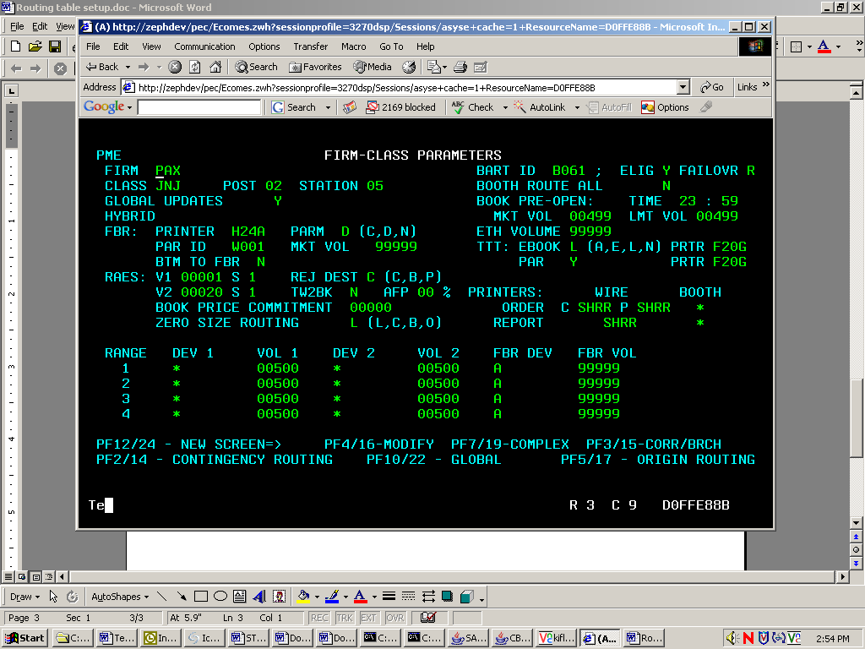

(F2)Contingency Routing Table Setup
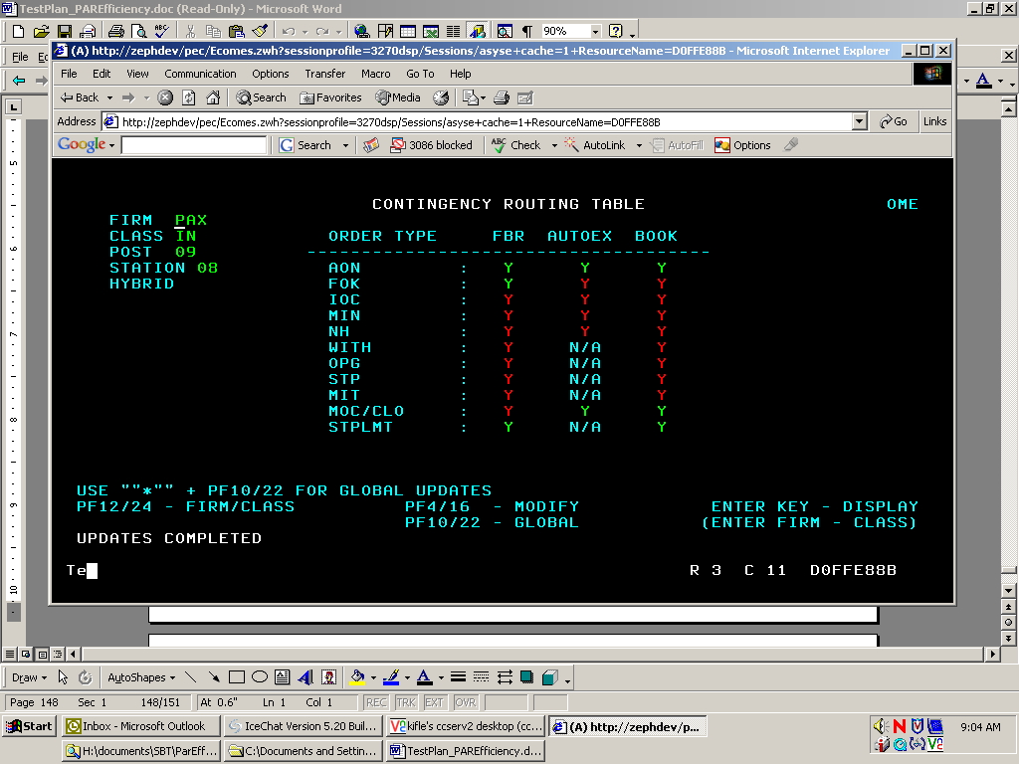

(F5) Simple Order Origin Routing Setup
- Set the ‘D’, ‘F’ & ‘I’, Origin type to route directly to PAR
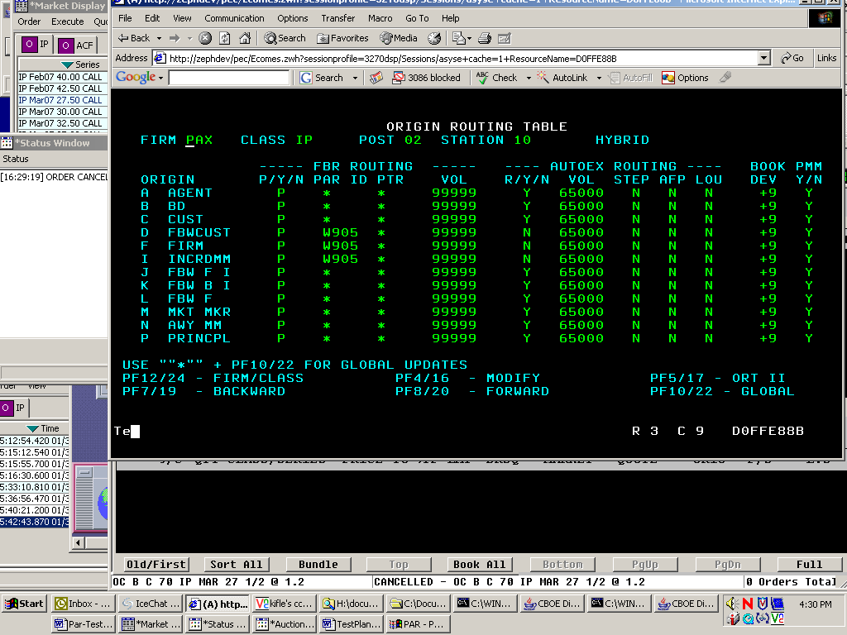

(F5 again) Order Origin Routing Setup (HAL)
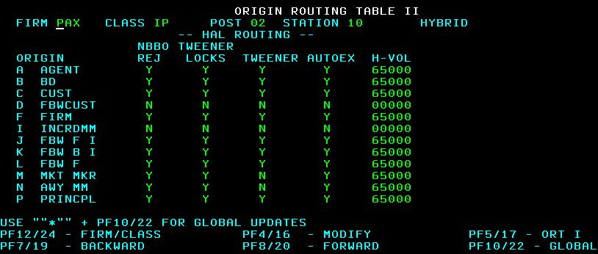

Menu 4 (F7) Complex Order Origin Routing Setup
- Set the ‘D’ & ‘F’ Origin type to route directly to PAR
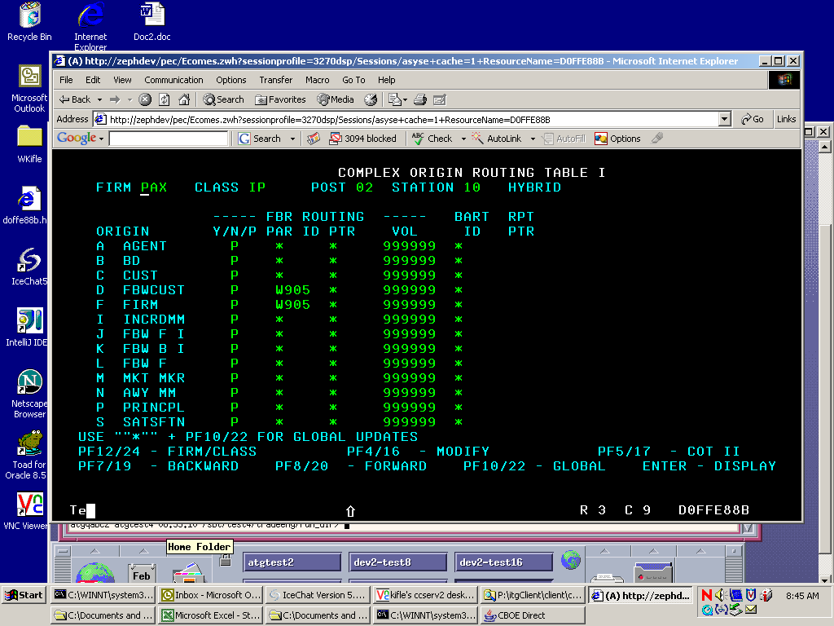

(F5) Complex Order Origin Routing Setup
- Set the ‘F’ Origin type for Auction
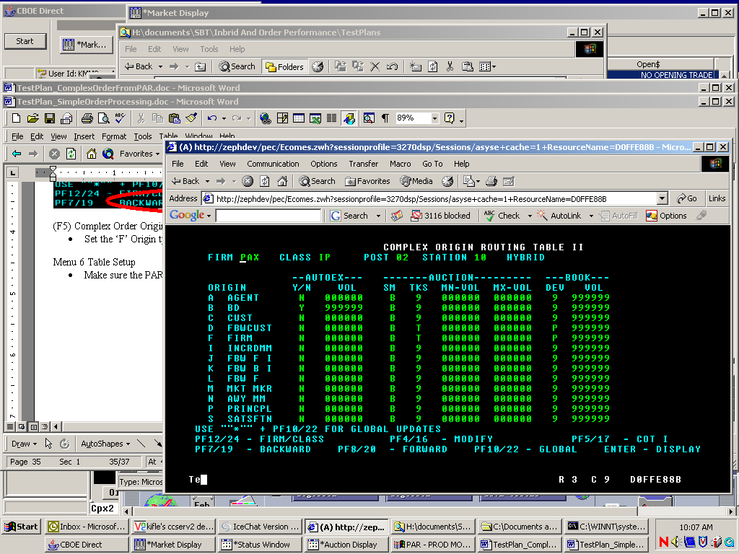
Menu 6 Table Setup
- Make sure the PAR ID matches your par station

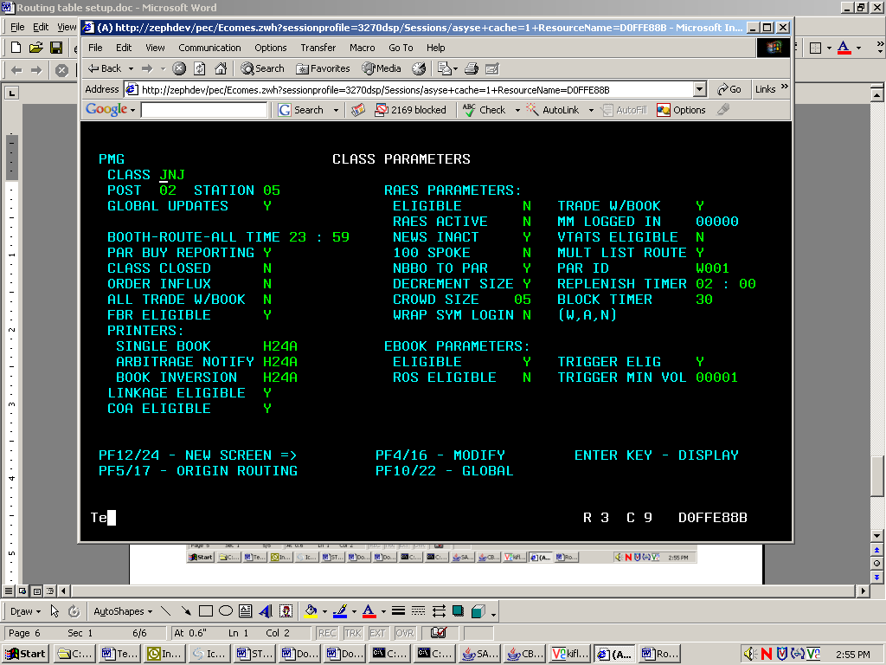
(F5) Class Origin Routing Table Setup
- Set the ‘D’, ‘F’ & ‘I’ Origin type to route directly to PAR

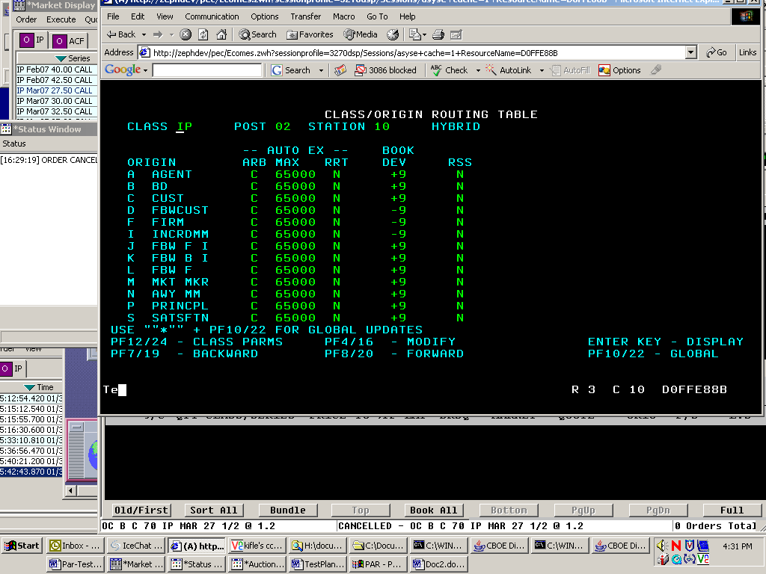

Make sure your class is enabled from TPF for Index Hybrid Processing

From the main Menu, Type in Class <your class symbol>, then Verify that the “Screen Based Trading” is set to ‘I’
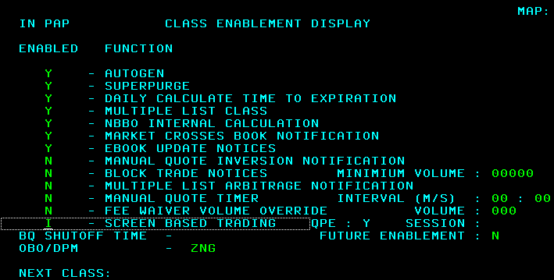

If your class is not enabled for Index Hybrid:

  - Stop Trading – type in “senote” and enter then Esc
  - Clear All Quotes – type in “eauto” and enter then Esc
  - Enable class for Index Hybrid – type in “class <class symbol>” and enter
  - Change the “Screen Based Trading” function from “H” to “I”
  - Start Trading – type in “sstpte” and enter then Esc
  - Start Quote – type on “sauto” and enter

